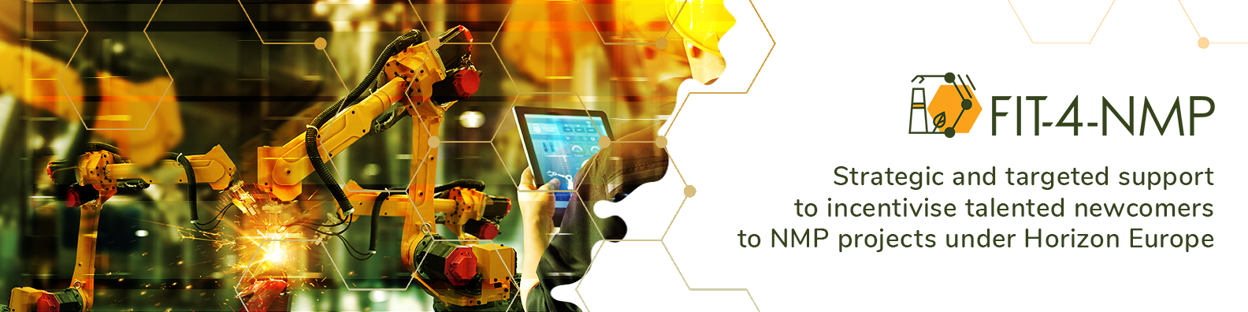
Title: FIT-4-NMP offering free support for the Horizon Europe Hop-On Facility

The European Commission recently officially opened the Horizon Europe Hop-On Facility. This facility enables one additional participant from a Widening country to join a project (i.e. with a signed grant agreement) funded under the Horizon Europe Pillar 2 or EIC pathfinder schemes, which does not already have a participant from a Widening country.

The Horizon Europe Hop-On Facility is open to all topics under the Pillar 2 and EIC pathfinder schemes and it has two cut-off dates: 20 April 2022 and 10 November 2022. To include the additional participant, an extra budget between 200,000 – 500,000 euro can be requested with up to 10% allocated to the coordinator of the consortium.

Meanwhile, FIT-4-NMP is a support action (Grant Agreement 958255) to increase the participation of talented newcomers from underrepresented regions in Horizon Europe in advanced materials, manufacturing technologies, clean industries and circular industries.

Therefore, FIT-4-NMP is offering the following free service to projects funded under the Horizon Europe Pillar 2 or EIC pathfinder schemes:

- Practical support to find a participant from a Widening country involved in advanced materials, manufacturing technologies, clean industries or circular industries,
- Practical help to provide the participant’s information for the Part A (e.g. administrative details, budget, etc.) and Part B (e.g. new task description, etc.) for an application to the Hop-On Facility,
- Practical assistance to prepare a grant amendment to include the participant.

If you are involved in, or aware of, a soon-to-start or recently started project (Pillar 2 or EIC pathfinder) and you are interested in FIT-4-NMP’s free service, then please feel welcome to send an email enquiry to fit-4-nmp@intelligentsia-consultants.com.

Also, please feel welcome to disseminate this FIT-4-NMP offer to a wider community.

FIT-4-NMP website: https://www.fit-4-nmp.eu

